TASK | Paint applied to Flexi trucks and accessories
LOCATION OF USE | Workshop |  | Assessment  No |  | 027
PRODUCT NAME | Ultrithane
DESCRIPTION OF SUBSTANCE | Red/black liquid paint
MANUFACTURER | Ultrimax Coatings Ltd
MANUFACTURERS CONTACT | Shaw Lane Industrial Estate  Ogden Road  Doncaster  DN2 4SE  01302 856666
ASSESSOR | Martin Monaghan CMIOSH |  | Date |  | 04 12 25
TITLE | Health and Safety Consultant |  | Review by |  | 04 12 27
Personnel Performing Task  (Please list below)  Workshop Operatives |  | Time Spent  (Minutes/day)  As and when required, amounting to a few minutes per day | Training Given 
 |  |  | Yes

MSDS Revision Date | Hazard Statement
01/04/2015 | H226 Flammable liquid and vapours  H304 May be fatal if swallowed and enters airways.  H336 May cause drowsiness or dizziness.

Assessment to be conducted in Association with Hazard Data Sheets, a full current copy of which must be attached to this assessment.

Please denote the hazardous properties of the substances used in the task with a 

NEW INTERNATIONAL GLOBALLY HARMONISED HAZARD SYMBOLS
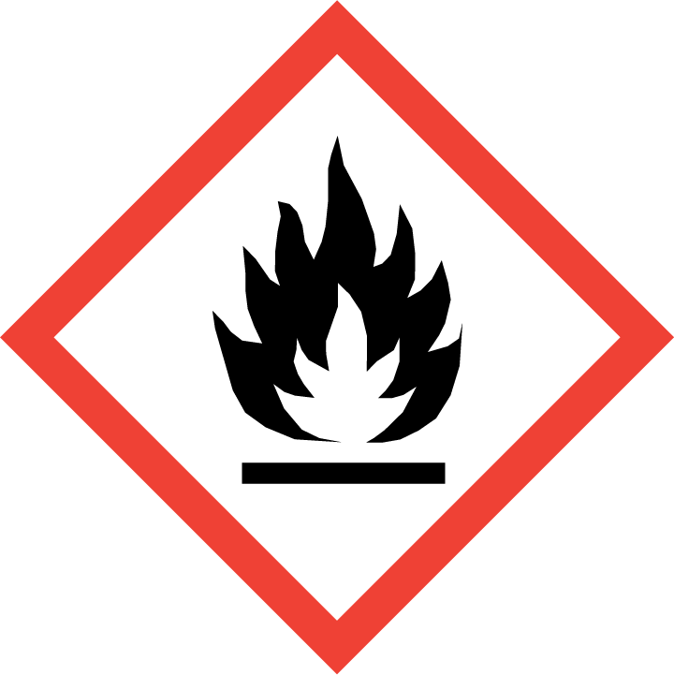 | 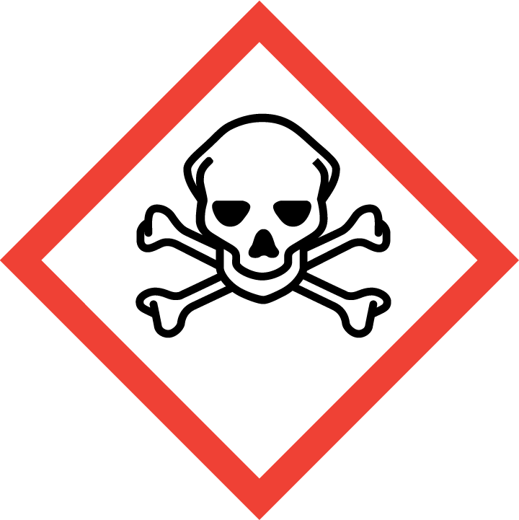 | 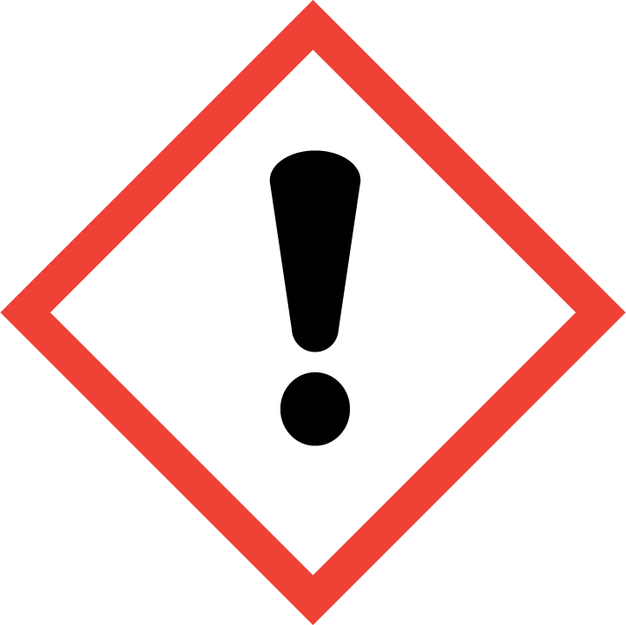 | 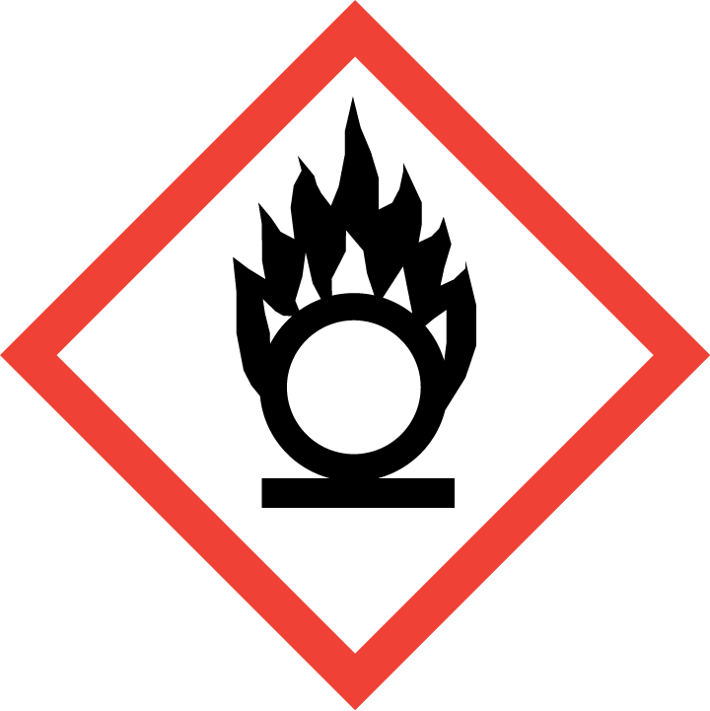 | 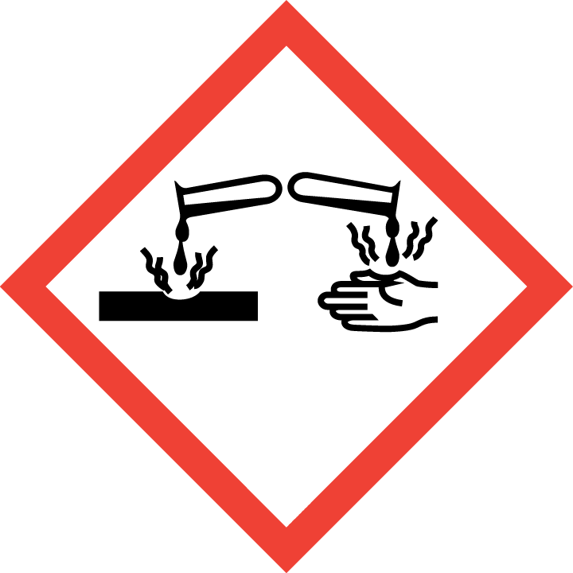 | 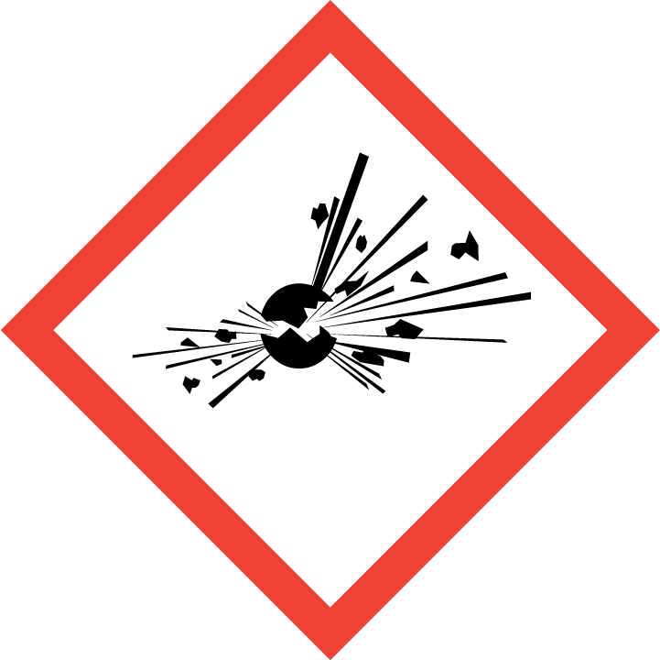 | 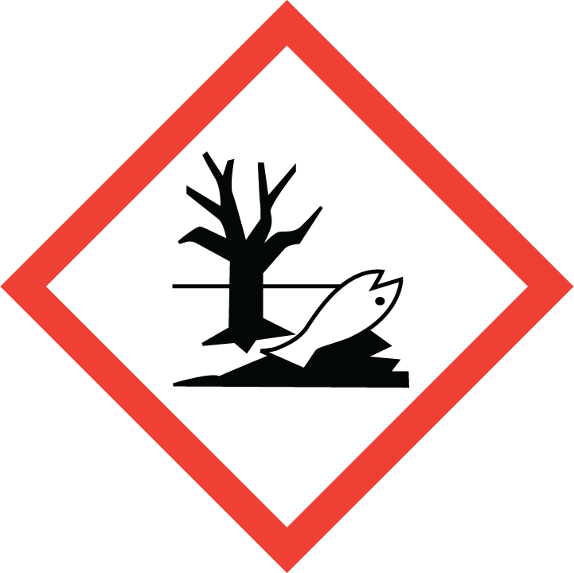 | 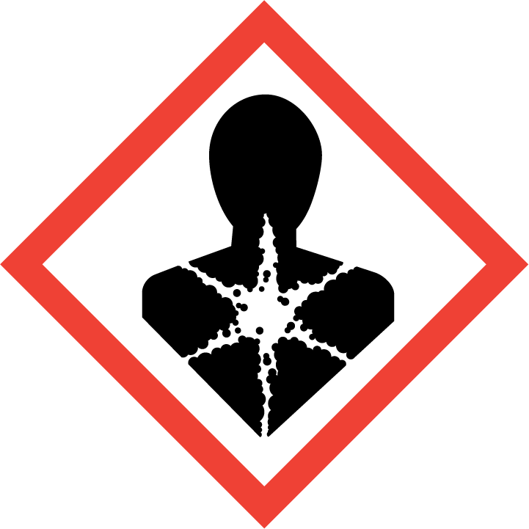
Flammable | Toxic | Danger | Oxidising | Corrosive | Explosive | Harmful to the environment | Health Hazards i.e. respiratory sensitisation or carcinogenicity
 |  |  |  |  |  |  | 

SMOKING, EATING AND DRINKING ARE PROHIBITED IN THE WORK AREAS.
Information, Instruction and Training must be provided to all users. Young Persons, New or Expectant Mothers and other vulnerable groups must not use or be exposed to this product.

WORKPLACE EXPOSURE LIMITS (WEL’s)
IMPORTANT!
Refer to Workplace Exposure Levels information provided in the Manufacturers Safety Data and revise control measures if exposure levels likely to be reached.

ROUTE OF EXPOSURE
Skin |  | Eyes |  | Inhalation | 
Ingestion |  | Cuts/abrasions |  | Systemic | 

PERSONS AT RISK
User of product |  | Co workers |  | Members of the public

ROUTE OF EXPOSURE | 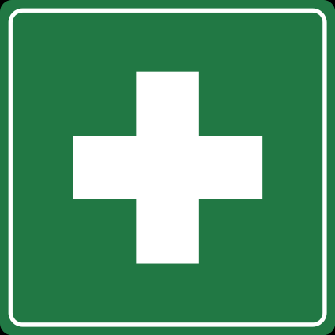  FIRST AID MEASURES
Eyes | Immediately flush eyes with plenty of water, occasionally lifting the upper and lower eye lids. Check for and remove any contact lenses. Continue to rinse for at least 10 minutes. Get medical attention.
Skin | Remove contaminated clothing and shoes. Wash skin thoroughly with soap and water or use recognised skin cleanser. Do NOT use solvents or thinners.
Inhalation | Remove to fresh air. Keep person warm and at rest. If not breathing, if breathing is irregular or if respiratory arrest occurs, provide artificial respiration or oxygen by trained personnel.
Ingestion | If swallowed, seek medical advice immediately and show the container or label. Keep person warm and at rest. Do NOT induce vomiting.
In all cases of doubt, or if symptoms persist seek medical attention. Never give anything by mouth to an unconscious person. If unconscious, place in recovery position and seek medical advice.

PERSONAL PROTECTIVE EQUIPMENT
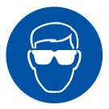 |  | 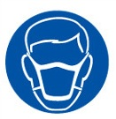 | 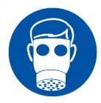 | 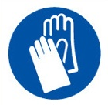 | 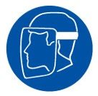
YES | YES | YES/NO | YES | YES | YES/NO
Safety glasses or goggles to EN166 | Suitable long sleeved coveralls. |  | Air fed masks EN 270 | PVC or rubber nitrile gloves. EN374

HANDLING | STORAGE | TRANSPORT | DISPOSAL
Avoid contact with eyes, skin and clothing. Use only with adequate ventilation. Wear appropriate respirator when ventilation is inadequate Do not enter storage areas and confined spaces unless adequately ventilated. Keep in the original container or an approved alternative made from a compatible material, kept tightly closed when not in use. | Store and use away from heat, sparks, open flame or any other ignition source. Use explosion-proof electrical (ventilating,  lighting and material handling) equipment. Use only non-sparking tools. Take precautionary measures against electrostatic  discharges. Empty containers retain product residue and can be hazardous. Do not reuse container. | Harmful paint | Any waste material is classed as hazardous waste, it should only be disposed of through licenced waste handlers and  treatment sites. Do not allow unauthorised disposal to the environment. Avoid sources of ignition when handling waste. If operators are exposed to vapours during the disposal process then suitable respiratory protection should be worn. All other personal protective equipment should be worn.  When handling waste, consideration should be made to the safety precautions applying to handling of the product.

REQUIRED CONTROL MEASURES
- Users to avoid contact with skin and eyes, and inhalation of vapours/ spray or mist arising from the application of this preparation – Use PPE.
- Respiratory protection if there’s a risk of exposure to high vapour concentrations.
- PVC or rubber gloves.
- Chemical goggles if there is a risk of eye contact.
- Normal work wear.
- Ensure operatives are made aware of and understand the purpose of this assessment and MSDS, plus any health implications of using the product.

FIRE PRECAUTIONS
Suitable: In case of fire, use water spray, foam, dry chemical or CO2.
Not suitable: Do not use water jet.

ACCIDENTAL RELEASE/SPILLAGE PROCEDURES
Evacuate surrounding areas. Keep unnecessary and unprotected personnel from entering. Do not touch or walk through spilt material. Shut off all ignition sources. No flares, smoking or flames in hazard area. Avoid breathing vapour or mist. Provide adequate ventilation. Wear appropriate respirator when ventilation is inadequate. Put on appropriate personal protective equipment.

MONITORING REQUIREMENTS AND HEALTH SURVEILLANCE
Annual Health surveillance is place for workers exposed to this product (Lung function and Urine samples)

